NAME: THULASI.S
DATE:24.01.26 ROLL NO:241901118

EXPERIMENT 1
WINDOWS FUNDAMENTALS

AIM:
To study the Windows operating system architecture, system configuration tools, file systems, processes, registry, and built-in security mechanisms.

ALGORITHM:
- Launch and access a Windows operating system.
- Explore system components, folders and configuration tools.
- Analyse processes, services and system management utilities.
- Study Windows security features and permissions.
- Observe monitoring, protection and auditing mechanisms.

TASKS:
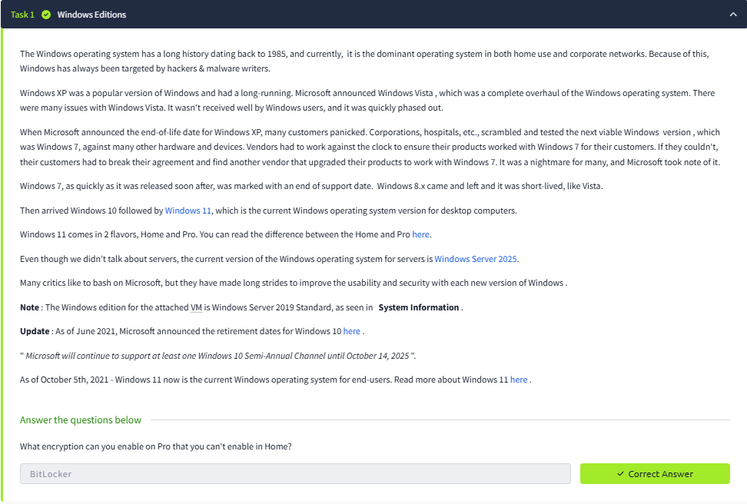
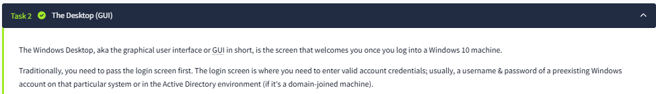
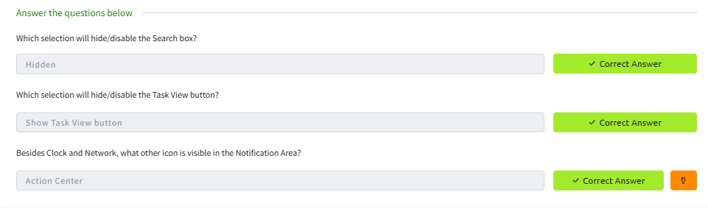
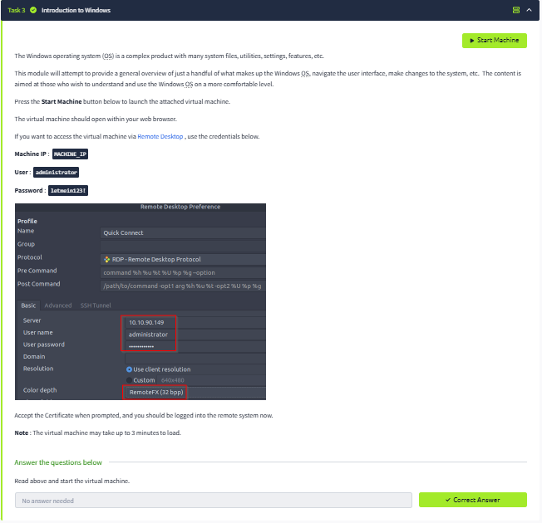
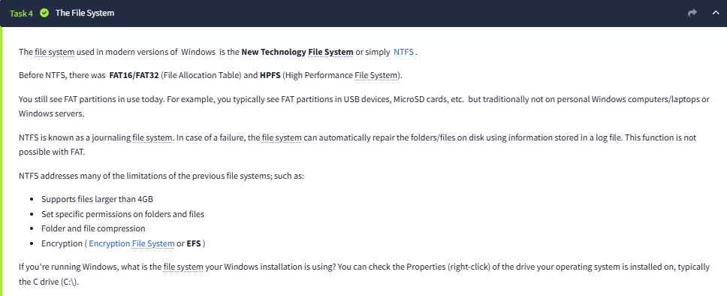
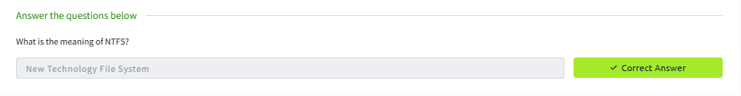
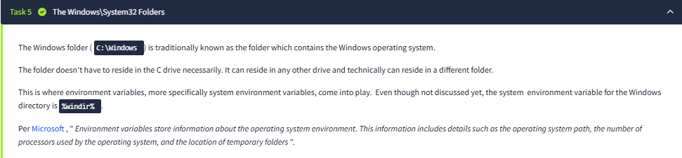
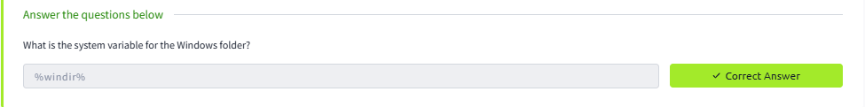
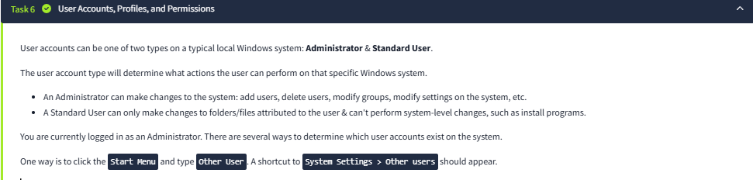
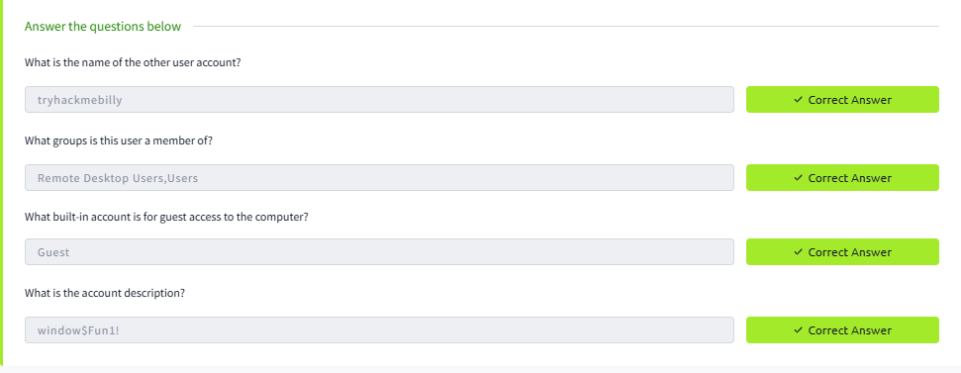
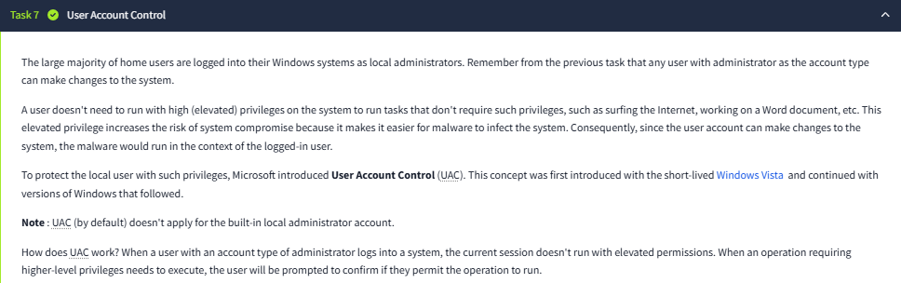
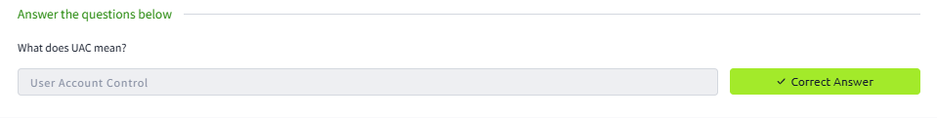
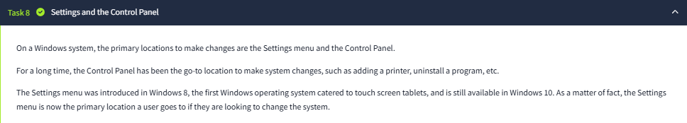
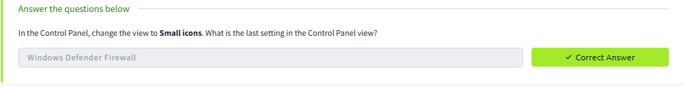
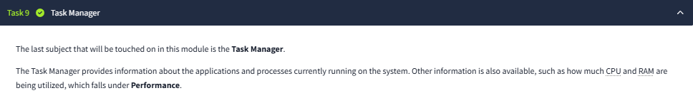
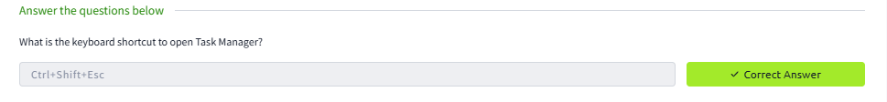
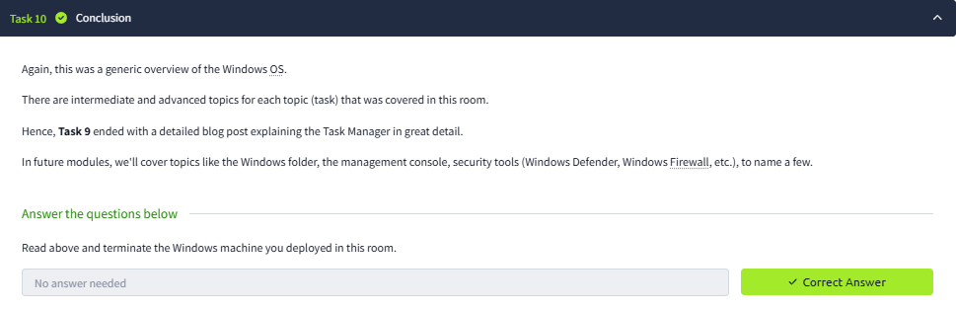
RESULT:
All the tasks in windows fundamentals tryhackme room were completed successfully.

